**How to create an accordion menu with Adobe XD**

**Create a menu item and the little triangle. Add a line below them.**

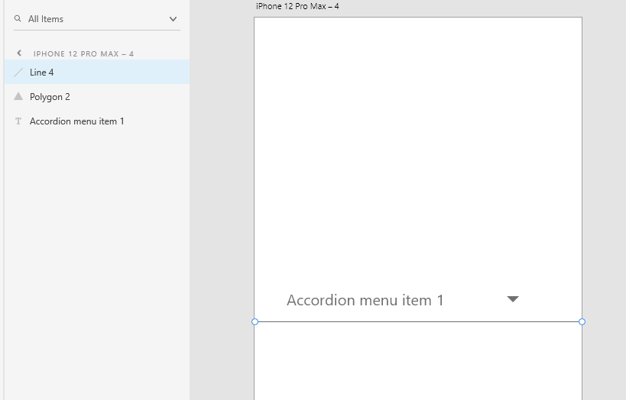

**Select all of them and group them as “Menu item 1”. Copy and paste the group to create more menu items**

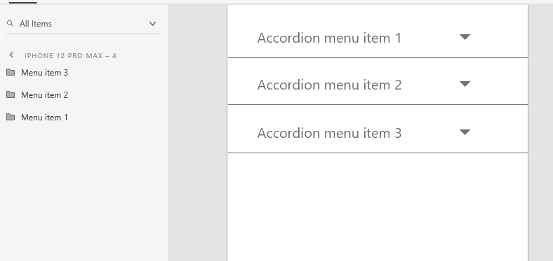

**Copy and paste the artboard**

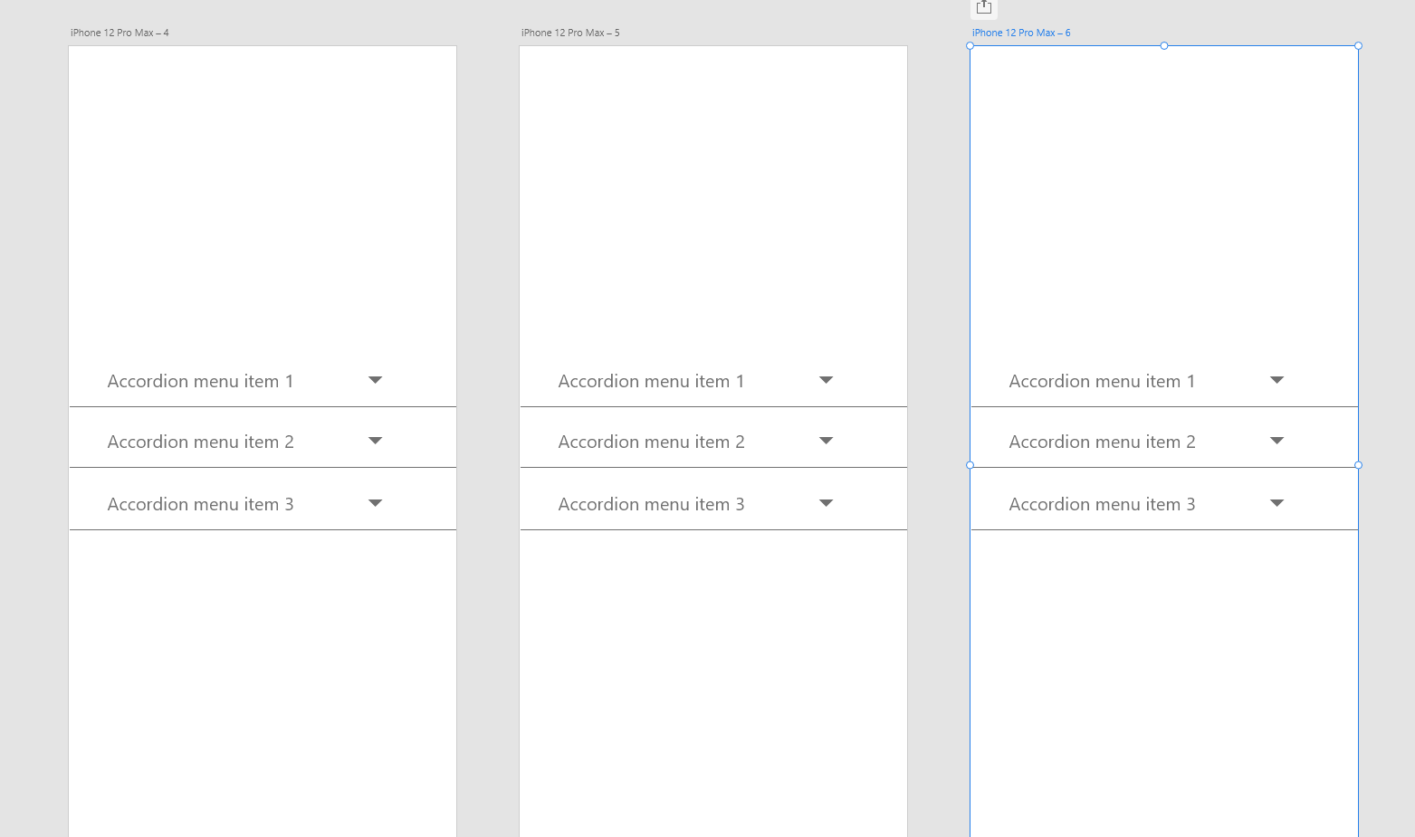

**Move the second and third items down in the second artboard**

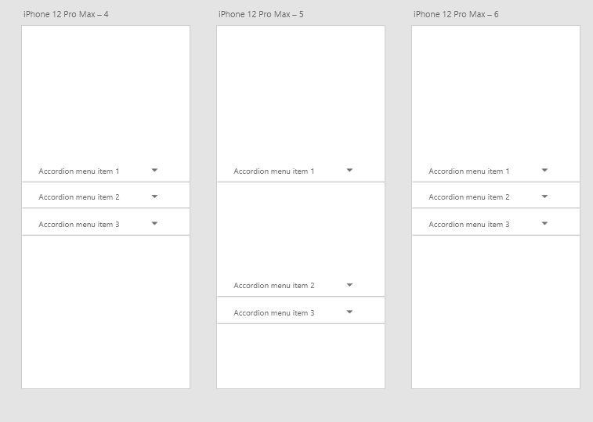

**Add some text for the open state of the item 1, and change the direction of the little triangle**

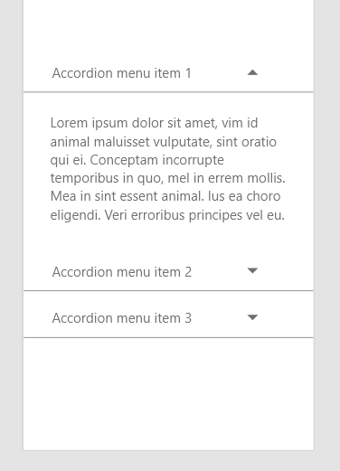

**Do similar thing to the second item of the third artboard**

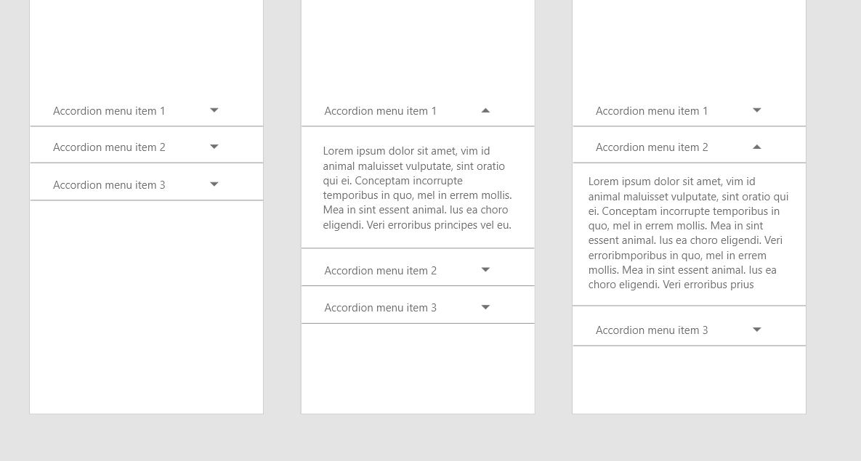

**In prototype, selection the first item of the first artboard, and drag to the second artboard**

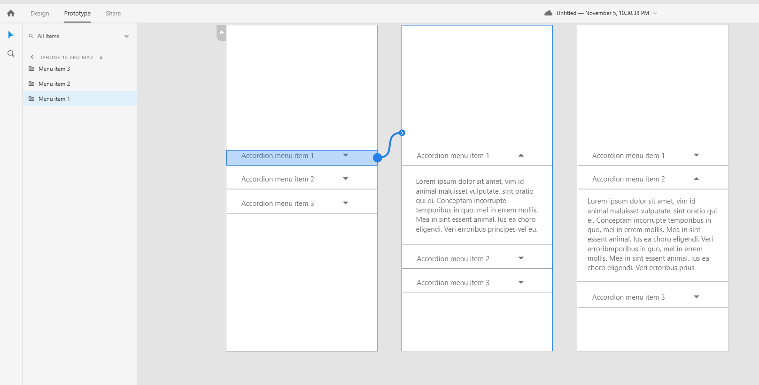

**Select the first item in the second artboard, and drag it back to the first artboard**

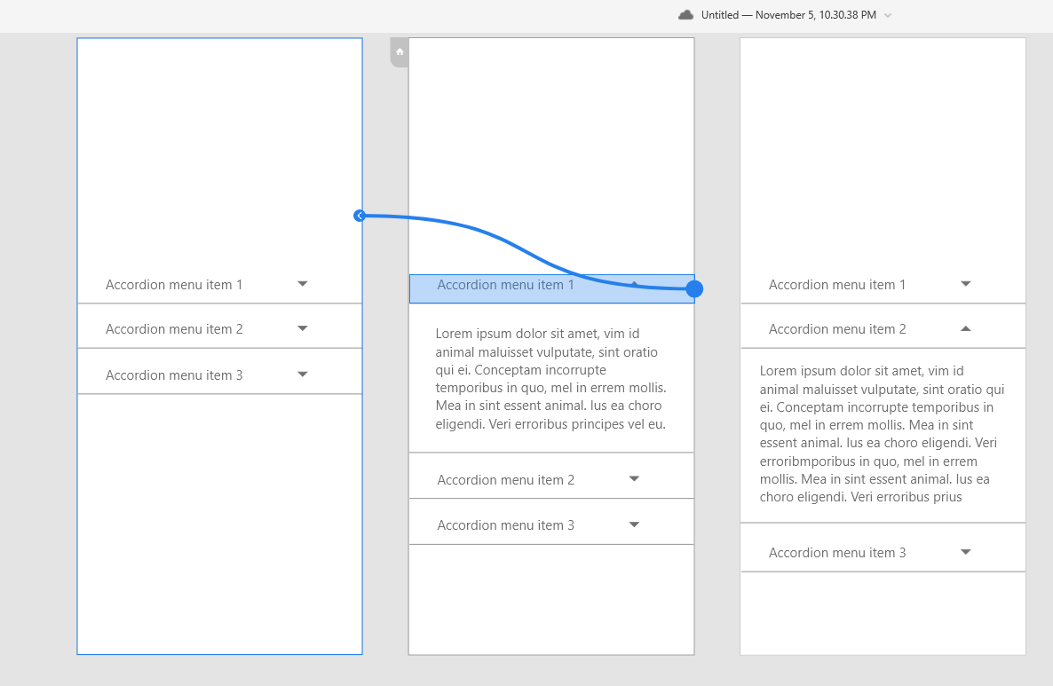

**Select the second item in the second artboard and drag to the third artboard**

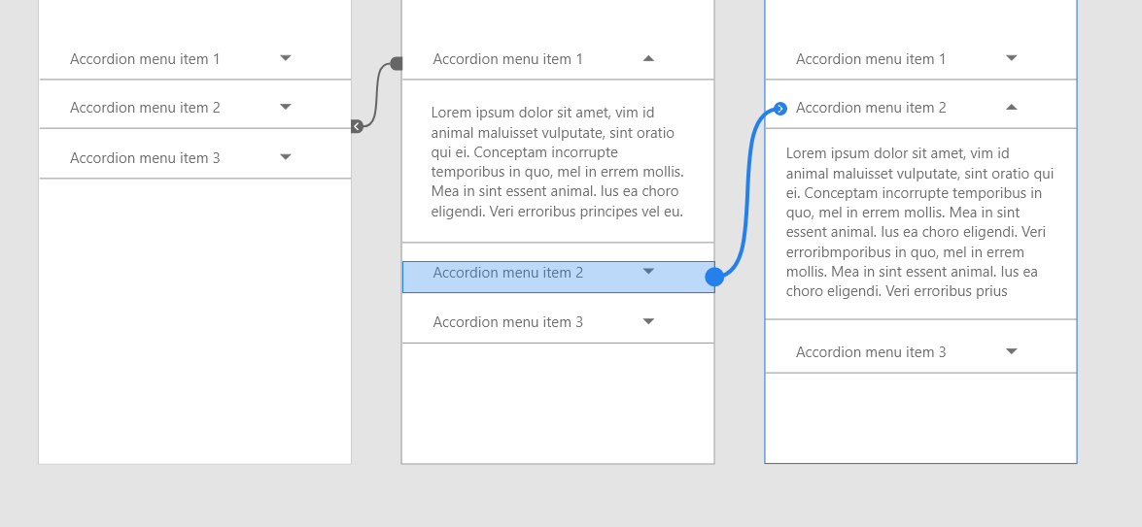

**Select the second item of the third artboard and drag back to the first artboard**

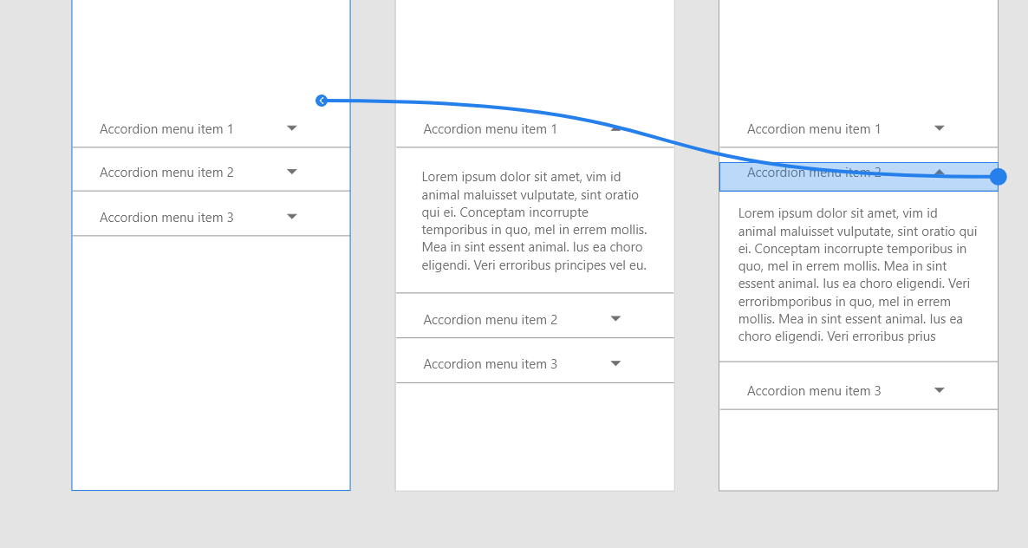

**Preview**

